IST769 Homework Submission Template

Basic Information
Your Name: Holden Herrell
Your SUID: 502591291
Your Email: hwherrel@syr.edu
Date Due: 11/2/2019
Homework #: 5

Instructions
For each answer, please include your answer as text, and any screenshot(s) which demonstrate your answer was executed. Most importantly, make sure to include evidence your answer is correct. This will most likely be a screenshot. If you had issues, problems, or had to make assumptions include them in your answer.

Your Answers:
1. This moved all the files to a folder in HDFS:
hdfs dfs -mkdir text
cd datasets/text
hdfs dfs -put * text
To call the list of files:
hdfs dfs -ls text
(I had lots of failed attempts between successful code lines, so clean screenshots were a near impossibility).
2.
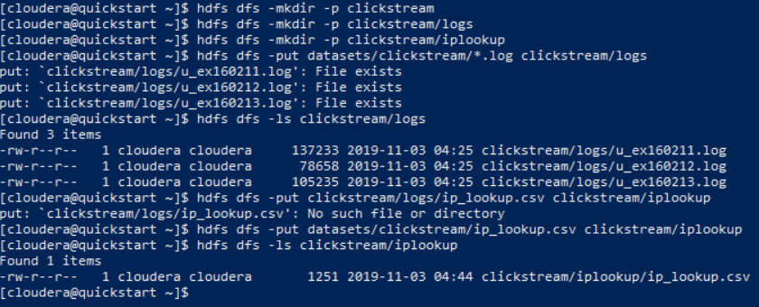
I had a very difficult time with this problem because I was getting lost in all the directories. I think I grasp the concept now, but HDFS vs local navigation was certainly a struggle.

3.
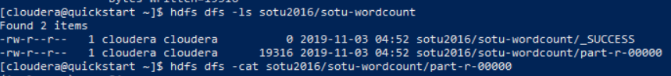
The word “are” appears 29 times. This wordcount would be more useful if it were not case sensitive and if it could recognize that punctuation should not be included as part of a word. I’m guessing this wordcount is using spaces as the separator between its values.
4.
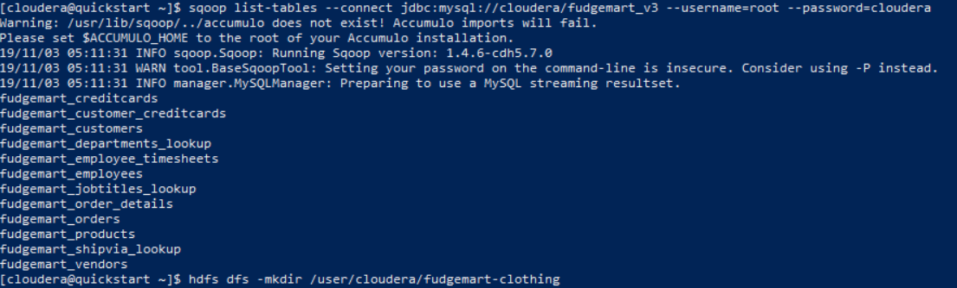
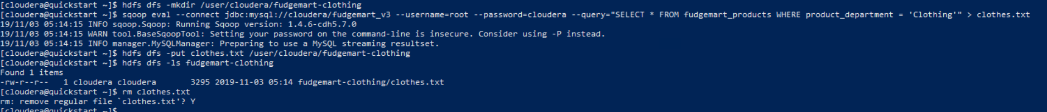

5. 